|  |  |
| --- | --- |
| Date | 28 June 2025 |
| Team ID | LTVIP2025TMID49154 |
| Project Name | Comprehensive Analysis and Dietary Strategies with Tableau: A College Food Choices Case Study |
| Maximum Marks | 4 Marks |

**8. Problem–Solution Fit**

**8.1 Recap of the Problem**

College students face multiple challenges that hinder their ability to maintain a healthy diet, such as:

* **Irregular meal patterns** due to hectic academic schedules
* **Lack of awareness** regarding nutritional values of food
* **Easy access to fast food** and limited affordable healthy alternatives
* **Minimal data-driven support** from institutions to encourage healthier behavior

These issues are not just isolated to individual health but can contribute to reduced academic focus, long-term health problems, and increased pressure on campus health services.

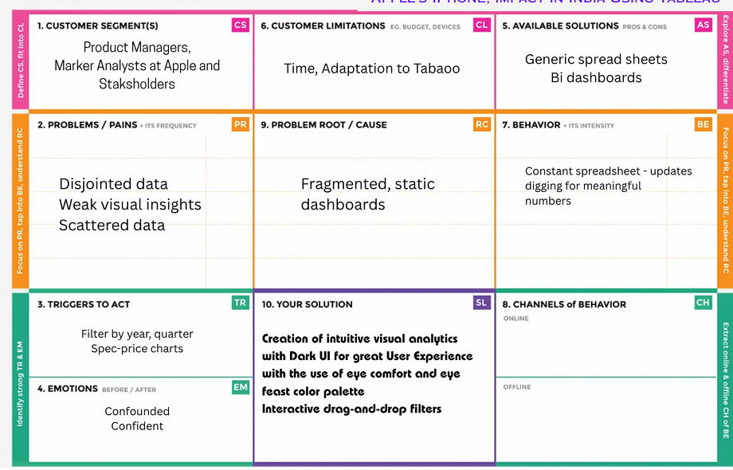 **8.2 The Proposed Solution**

The solution developed in this project addresses these concerns through an interactive, data-driven platform powered by Tableau and integrated via Flask.

| **Problem Area** | **Solution Feature** |
| --- | --- |
| Unawareness of diet impact | Tableau dashboards visualizing diet vs GPA, exercise, and health perception |
| Lack of real-time insight | Live and interactive dashboards with filtering by demographics and food habits |
| No personalized guidance | Visualization of ideal vs actual dietary behavior, enabling self-assessment |
| Hard to track food trends | Time-based visualizations showing fruit/veggie intake, junk food consumption |
| No intervention tools for institutions | Admin-level overviews to support awareness campaigns and strategic meal planning |

**8.3 How the Solution Delivers Fit**

| **Fit Dimension** | **Explanation** |
| --- | --- |
| **Target User Match** | Designed specifically for students, university staff, and campus nutritionists |
| **Insight Accessibility** | Visual storytelling converts complex datasets into digestible insights |
| **No Learning Curve** | User-friendly dashboards with no login or training required |
| **Actionability** | Enables both self-improvement for students and strategic actions for staff |
| **Scalability** | Can be extended with more data, filters, or even personalized student views |

**8.4 Strategic Value**

This solution does more than visualize data — it **empowers decision-making**:

* 🧑‍🎓 **Students** learn more about their own health habits
* 🏫 **Institutions** gain insights for policy, menus, and campus wellness programs
* 📊 **Data Analysts / Researchers** gain access to structured insights for ongoing study

In essence, the system builds a bridge between data and well-being — making health awareness **visual, personal, and actionable**.